Smart Makers Slicer Installation and Config.

1. Double click the “cura_17.10.exe” to start the installation. Browse the destination if you like.

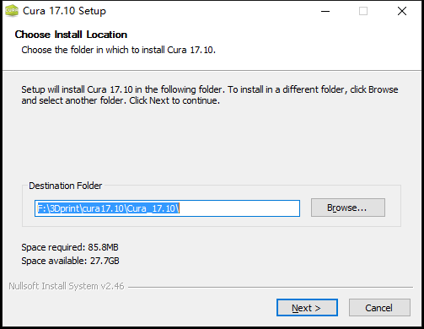

1. Click Next and Install to start the program. It would take a few minutes (left picture).

A new window would jump out, Click Next and Finish for the Device Driver Installation Wizard window (Right Picture).

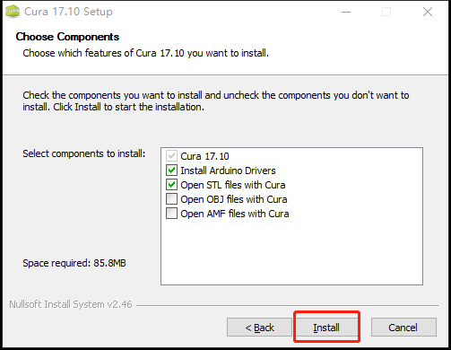 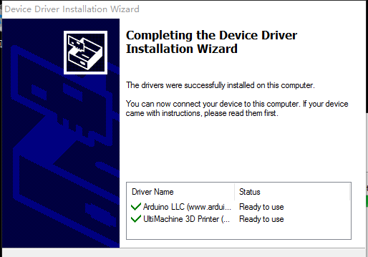

1. Installation is done.

Check the “Start Cure 17.10” then click the Finish.

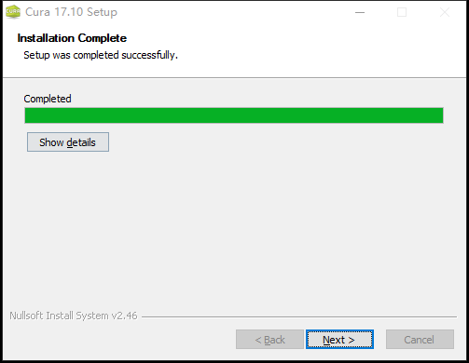 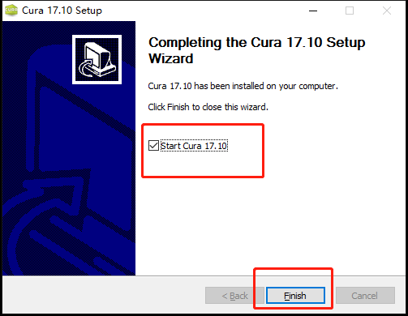

1. Select Other Printers, and Next.

Select Other, and Next.

Select Custom, and Next.

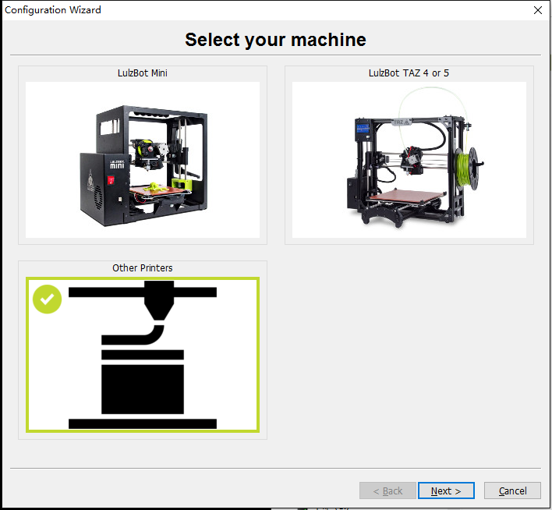 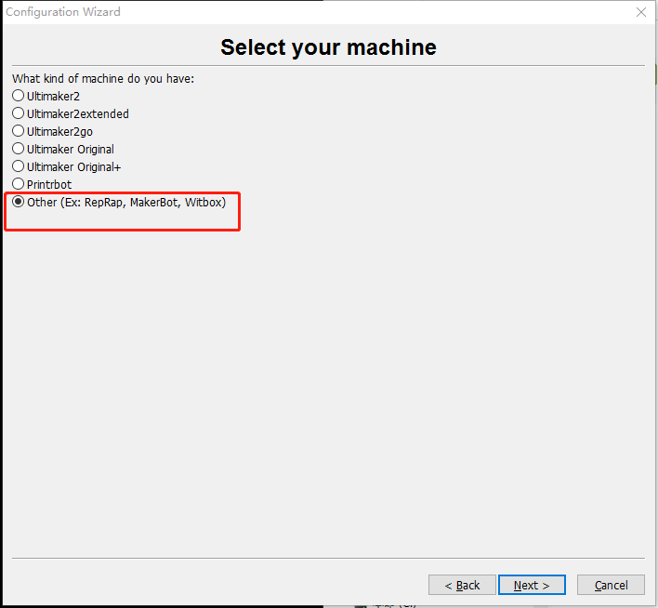 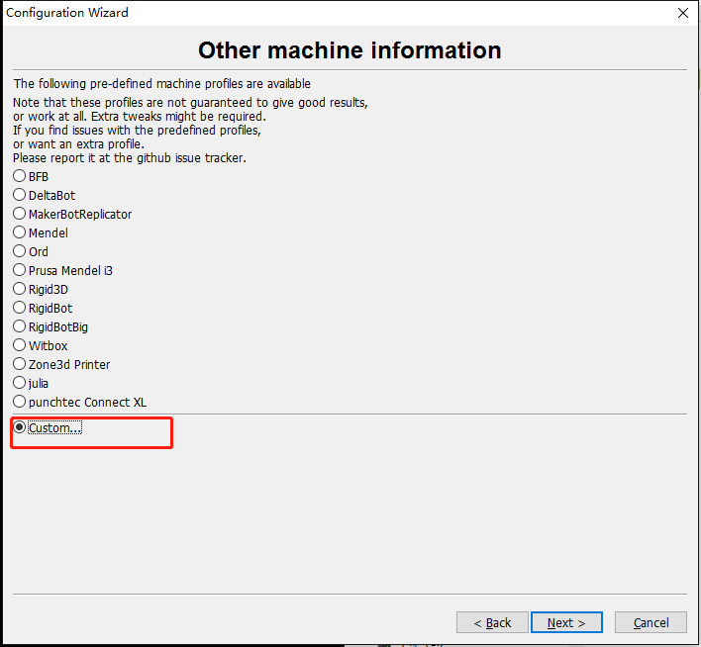

1. Machine Name “SmartMaker”

Machine Width X(mm) “235”

Machine Depth Y(mm) “235”

Machine Height Z(mm) “300”

Nozzle Size (mm) “0.4”

Heated bed “check”

Bed Center “blank”

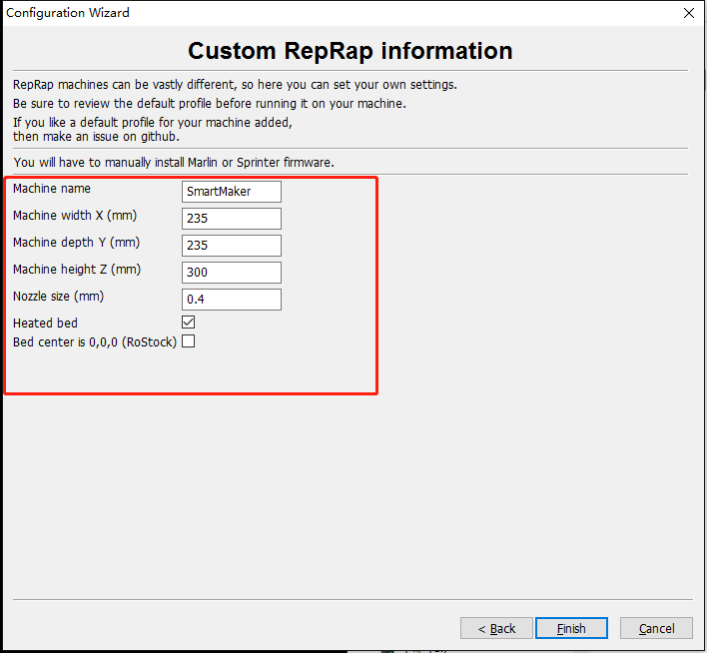

1. Click “File”, select “Open Profile”

Select the file named “MakerSpace_SmartMaker_config.ini”.

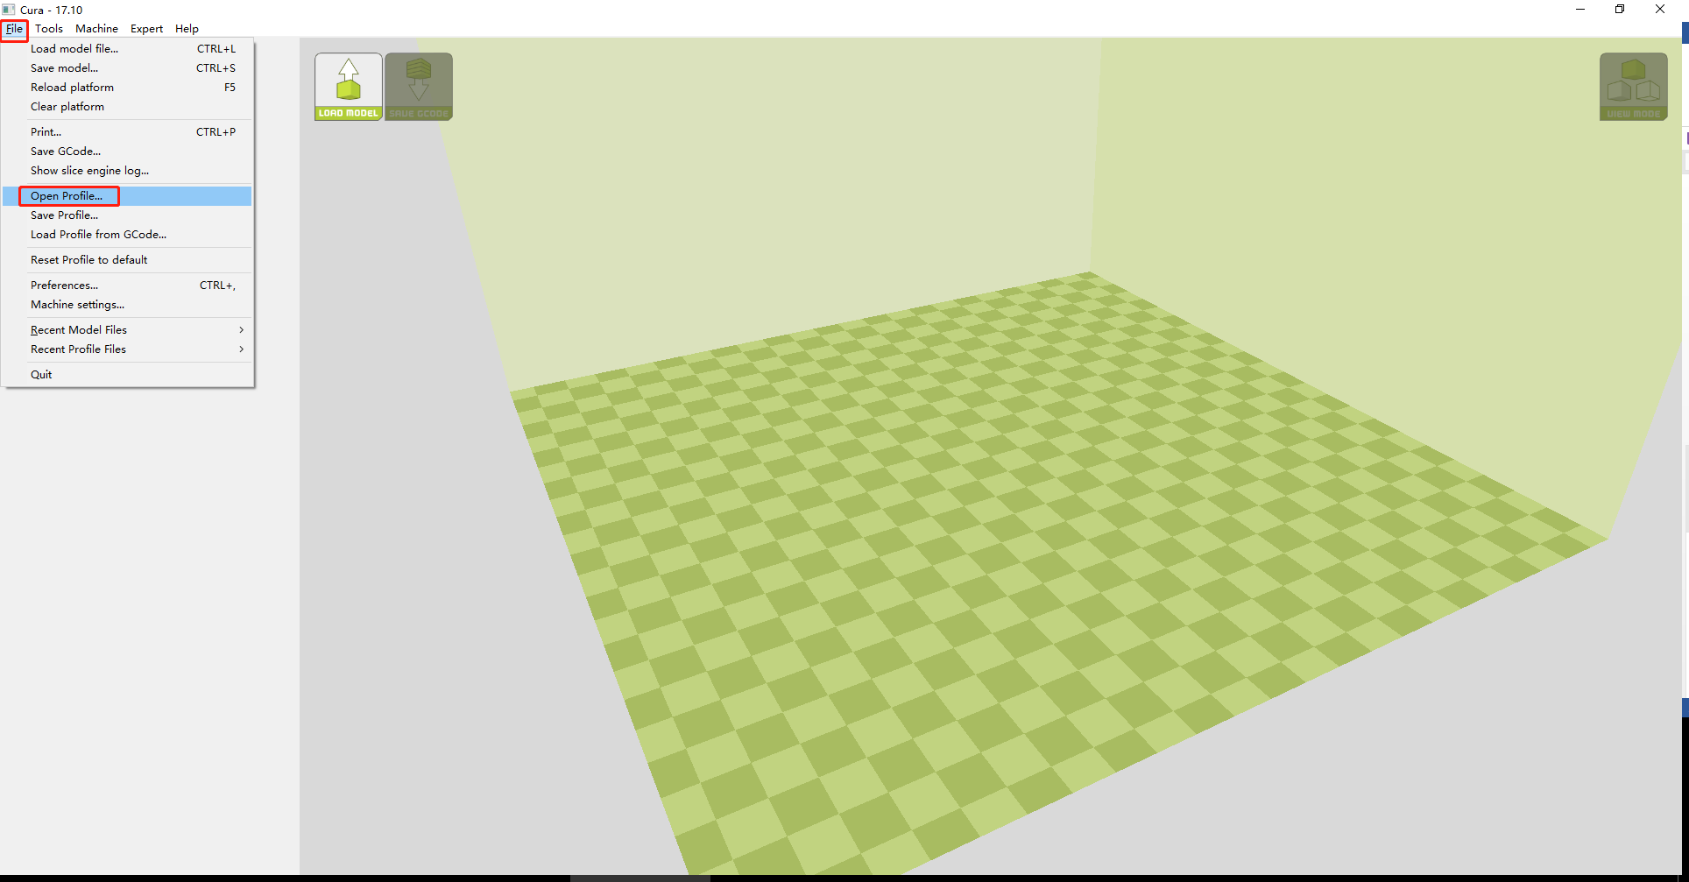 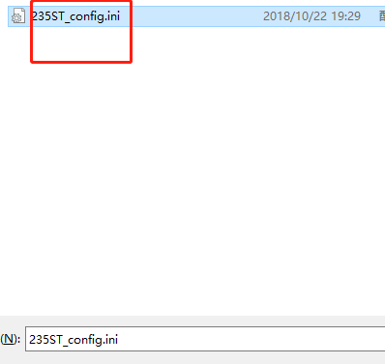

1. Close the ‘’Cura”, then open it again.

Now we can load the STL files.

Cura will slice the model automatically, now you can save the gcode to SD card and then print it! Enjoy!

